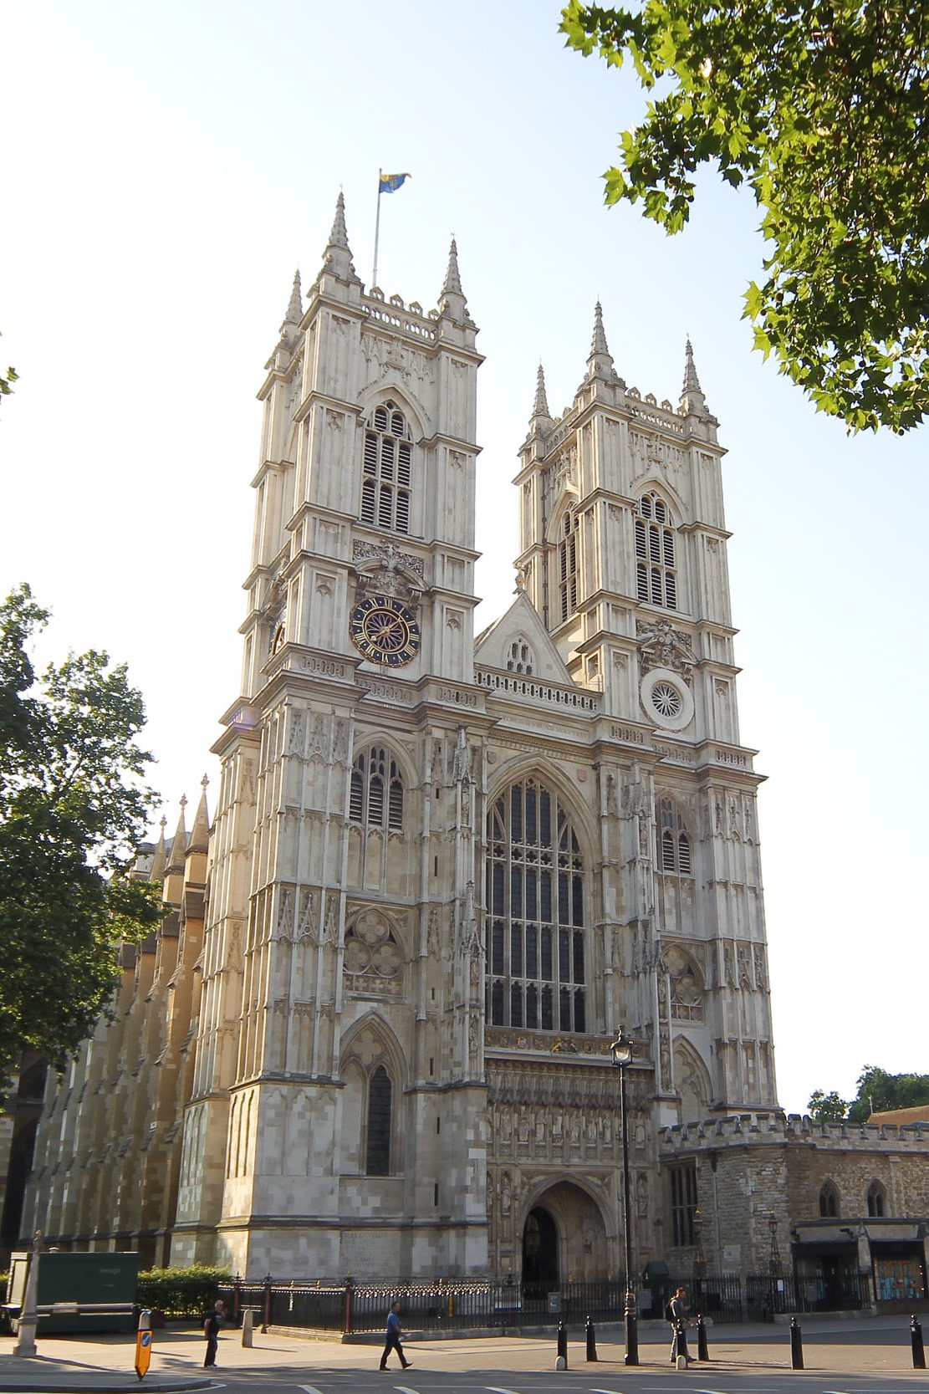

Minor Canons Administrative Support Officer

Salary £32,860 per annum

Full-time – Permanent

40 hours per week

Westminster Abbey

Application pack
westminster-abbey.org



Contents

- About Westminster Abbey
- Job description and Person Specification
- Working for us
- Equality statement
- Safeguarding
- How to apply

About Westminster Abbey

Above all else, the Abbey is a church, a place of prayer and praise and holy ground at the heart of the nation. It is also a treasured part of Britain’s heritage and a leading venue for tourism. The Abbey has occupied a central place in the celebration of great events for the nation and remains one of the most beautiful architectural masterpieces in Britain.

A living Church, Westminster Abbey is where the coronation of Kings and Queens has taken place since 1066, and where many of the Kings and Queens of England and of the United Kingdom are buried. Principal among them is St Edward the Confessor, King of England from 1042 to 1066, whose shrine is at the heart of the Abbey Church. Beside and around them are buried or commemorated many of the great women and men from almost every century of British history: statesmen and politicians, lawyers, warriors, clerics, writers, artists, musicians.

Neither a cathedral nor a parish church, Westminster Abbey (or the Collegiate Church of St Peter in Westminster to give it its correct title) is a Royal Peculiar under the jurisdiction of a Dean and Chapter and with direct accountability to the Sovereign. This relationship with the Sovereign dates back to the origins of the Abbey over a millennium ago, but its current form stems from the Charter granted to the Abbey by Elizabeth on 21st May 1560.

We are a welcoming community, but also complex and multi-faceted, with over 600 highly committed employees and volunteers. We have deep respect for the heritage of which we are the custodians, but we evolve continuously to meet the opportunities of the future. In recent times this has included the creation of new departments to focus on transforming our digital presence and delivering a significantly expanded programme of public and community engagement.

Westminster Abbey’s mission is:
- To offer daily divine Worship to Almighty God and resource the Church in this vocation;
- To serve the Sovereign;
- To proclaim the Gospel to the nation and Commonwealth, celebrating the distinctive witness of the Christian faith and engaging with the public square;
- To provide a safe, welcoming and inspiring environment for all who come to the Abbey;
To care for the precious resources entrusted to us: our people, partnerships, buildings, heritage and money.

Following the State Funeral of Her late Majesty Queen Elizabeth II and the Coronation of Their Majesties The King and Queen, which were broadcast to national and international audiences in their millions, interest in the Abbey is very strong. We attract approximately 1.4 million visitors from around the world every year. As we receive no regular income from the State, the Church of England or the Crown, we rely almost entirely on income from visitors.
It is an exciting time to join the Abbey, and we look forward to receiving your application and if successful, welcoming your contribution to the Abbey’s history.

Job description

JOB TITLE: | Minor Canons Administrative Support Officer
DEPARTMENT: | Westminster Abbey Minor Canons
JOB SUMMARY: | The Minor Canons Administrative Support Officer will provide day-to-day administrative and organisational support to the Office of the Minor Canons, reporting directly to the Precentor. The postholder will support the work of the whole department, ensuring smooth communication, accurate record-keeping, and efficient administrative processes.  This role is essential in enabling the Minor Canons team to deliver services and departmental projects effectively, by maintaining strong administrative systems, pro-active and clear communications and providing reliable day-to-day support.
BACKGROUND | Westminster Abbey is both a place of daily worship and one of the UK’s leading visitor attractions, welcoming over one million visitors each year. A diverse and lively community work at the Abbey comprising just over 350 employees and a greater number of volunteers. Westminster Abbey defines its main mission as the worship of Almighty God. The Office of the Minor Canons, under the authority of the Dean, is responsible for the production and organisation of services of national and international significance, and the daily round of worship.

MAIN DUTIES AND RESPONSIBILITIES:

- Provide general administrative support for the Precentor and Minor Canons and for other team members as directed by the Precentor.
- Manage departmental correspondence, including emails, letters, and internal communication.
- Maintain departmental files and records, both digital and paper, ensuring accuracy and accessibility.
- Support departmental meetings, including preparing agendas, circulating papers, taking minutes, and tracking actions.
- Assist with diary management and communications for the Precentor.
- Assist with scheduling meetings for all Minor Canons.
- Coordinate internal communications, ensuring information is shared effectively and in a timely way.
- Assist with departmental administration and coordination of volunteer groups and oblates.
- Support the Assistant to Minor Canons (Special Services & Visiting Choirs) with Visiting Choirs administration and coordination.
- Provide administrative support to the Succentor for the ‘Resourcing the Church’ project.
- Provide administrative cover when Assistants to Minor Canons are absent (including printing and distribution of service papers)
- Undertake other administrative duties as required to ensure smooth departmental operation.

Person Specification
This section outlines the knowledge, skills and abilities that the role holder needs in order to fulfil the requirements of the post. ‘Essential’ criteria are those that the role holder absolutely must have in order to perform the role and are the key areas to be assessed during the probationary period. ‘Desirable’ criteria are those qualities that would be either useful, or an advantage or those which the role holder can be trained to do.
ESSENTIAL
Education/Training/Qualifications
- Educated to A-level standard or equivalent professional experience in an administrative role.
- Evidence of ongoing professional development or training in areas such as administration, or service/event coordination.
Knowledge/Experience:
- Experience of providing administrative support in a busy office or organisational setting.
- Experience of managing correspondence and maintaining accurate records.
- Experience of scheduling and supporting meetings, including minute-taking.
- Experience of working with different stakeholders and colleagues across departments.
Skills/Aptitudes:
- Excellent organisational skills with the ability to manage routine tasks efficiently.
- Strong administrative and record-keeping skills with attention to detail.
- Good ICT skills, including Microsoft Office (Word, Excel, Outlook, PowerPoint) and confidence with digital systems.
- Strong written and verbal communication skills.
- Ability to prioritise workload and meet deadlines.
- Ability to work collaboratively in a small team environment.
- Discretion and reliability in handling sensitive information.
Aptitudes:
- Well-organised, reliable and proactive.
- Able to remain calm and professional under pressure.
- Commitment to the Abbey’s values, ethos and mission.
- Flexible and adaptable approach to work, with a willingness to support colleagues as needed.
- Professional, approachable and collaborative manner.
DESIRABLE
Knowledge/Experience:
- Familiarity with the liturgy and worship of the Church of England.
- Understanding or appreciation of the choral tradition.
- Experience of working within a heritage, cultural, or faith-based organisation.
- Experience of supporting senior staff in a professional environment.
This Job Profile will be kept under review and may be amended by the Dean & Chapter from time to time. Any proposed changes will be discussed with the postholder.
Westminster Abbey is committed to the safeguarding of children, young people and adults at risk. To prevent them from harm, we undertake appropriate checks (including the relevant level of criminal record check) on staff and volunteers and require them to complete relevant safeguarding training. This post requires a basic level criminal check.

Working for us

Employment Status
This post is permanent.

Salary
The salary is £32,860 per annum and is paid on the last Friday of each month. Salary is reviewed annually.

Working Hours
These are 40 hours per week. The normal arrangement of working hours is 9am to 5pm Monday to Friday however the postholder will be required to work hours that suits the needs of the organisation.

Annual Holidays
The full-time holiday entitlement is 33 days per annum, including recognised public holidays.
Training
On-site training will be provided in all aspects of the job. Any further training needs will be assessed through the probation period and in annual appraisals.

Pension Scheme and Life Assurance
All employees can join a Group Personal Pension plan, where the minimum employee contribution is 3% and the maximum employer contribution is 9% (as determined by the level of the employee contribution). You will be auto-enrolled into our qualifying workplace pension scheme after 3 months, if you meet the eligibility criteria.

All employees are covered by death-in-service life assurance, whether or not they choose to join the pension scheme.

Staff Discount
All employees receive a 20% discount on purchases from the Westminster Abbey shop and a 30% discount on purchases from the Benugo outlets, which serve refreshments.

Season Ticket Loan
A season ticket loan is offered after satisfactory completion of a probationary period, repayable over 10 months.

Medical Insurance
The Abbey will pay 50% of premiums to join a nominated medical insurance scheme after one year’s employment.

Uniform
If a uniform and/or Personal Protective Equipment (PPE) is provided, this must be worn at all times.

Equality statement and
How to apply

Equality Statement
The Dean and Chapter aim at all times to recruit the person who is most suited to the job. Recruitment will be solely on the basis of the applicant’s abilities and individual merit as measured against the criteria for the job. Qualifications, skills and experience will be assessed at the level that is relevant to the job.

We will ensure that our shortlisting, interviewing and selection procedures avoid discrimination in any way, including on grounds of age, disability, gender, marital status or civil partnership, race, nationality or ethnic origins, religion or belief and sexual orientation.

Please return the Equal Opportunities Monitoring Form with your application. This will help us monitor our recruitment practice. The form will not be seen by the people making the selection decision.

Safeguarding
Westminster Abbey is committed to the safeguarding of children, young people and adults at risk. To prevent them from harm, we undertake appropriate checks on staff and volunteers and require them to complete relevant safeguarding training. Offers are subject to a relevant level of criminal record check, receipt of references satisfactory to Westminster Abbey, right to work in the UK, proof of professional qualifications and medical clearance, which may include a medical assessment.

How to Apply
Please complete our online application form as CVs will not be accepted.

You are also advised to read the Job Description and Person Specification carefully and think about how your experience, skills and abilities help you to meet the requirements listed in the Person Specification. Use the ‘Supporting Statement’ section of the form to tell us how you meet each of the requirements. As well as your previous work experience (including a full career history of all employment), tell us about other relevant experience such as community and voluntary experience. Clear information on how you meet all the requirements of the job, with relevant examples, will help us with shortlisting, and we may not be able to shortlist you for interview if you do not provide this.

Applications should arrive no later than midnight on 5 May 2026. Interviews are scheduled to take place on 13 May 2026.

We regret that, due to the large number of applications we normally receive, we may only be able to contact or provide feedback if you have attended an interview. We appreciate your interest in our work at Westminster Abbey.

